9.1.3 Editors - UV Editor - Header - Select Menu.odt
Select menu 1
All 1
None 1
Inverse 2
Box Select Pinned 2
Circle Select 2
Linked 2
Linked Pick 2
Last Operator Select Linked Pick 2
Extend 2
Deselect 2
Location X / Y 2
Pinned 3
Split 3
Overlap 3
Last Operator Select Overlap 3
Extend 3
Shortest Path 3
Last Operator Pick Shortest Path 3
Face Stepping 3
Topology Distance 3
Fill Region 3
Nth Element 3
Skip 4
Offset 4
More 4
Less 4

Select menu

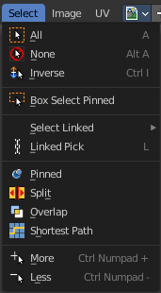
This menu just appears when you are in Mask mode. And you need to create a new mask layer to set all items active. The select functionality in this menu covers the mask geometry. The splines.

All
Select everything.

None
Select nothing.

Inverse
Invert the current selection.

Box Select Pinned
Box select enters the Border Select mode. This is a special select mode where you can select elements by dragging a rectangle. And what's inside of the rectangle gets selected then. It adds to selection by default. Box Select Pinned just selects pinned UV vertices. The other box select method can be found in the tool shelf.
To subtract from selection hold down Shift key.
The selection gets applied when you release the mouse. You leave the mode automatically when you release the mouse.

Circle Select
Circle select enters the Circle Select mode. This is a special select mode where you can select elements by moving with the mouse over it. It adds to selection by default.
To subtract from selection hold down Shift key. To exit the Circle select click with the right mouse button.
The pencil radius of the circle select tool can be adjusted with the scroll wheel.

Linked
Select all UV vertices linked to the active UV map. The previous selection gets cleared.

Linked Pick
Hotkey Only Tool!
Select all UV vertices linked to the active UV map. The previous selection gets cleared.

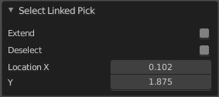
Last Operator Select Linked Pick

Extend
The previous selection gets kept, the selection gets extended.

Deselect
Deselect instead of select

Location X / Y
The mouse position in the UV space, normalized to the 0.0 to 1.0 range of the UV space.

Pinned
Select pinned UV vertices.

Split
Select only entirely selected faces.

Overlap
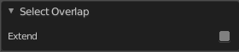
Select all UV faces that overlaps each other.

Last Operator Select Overlap

Extend
Extend the current selection.

Shortest Path
Select the shortest path between two selected elements.
Note that shortest path is a hotkey tool. Select the first element, hold down ctrl, select the second element.

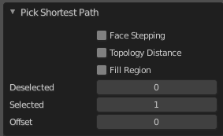
Last Operator Pick Shortest Path

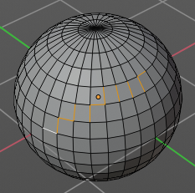
Face Stepping
Traverse connected faces.

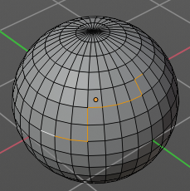
Topology Distance
Find the minimum number of steps instead of the shortest distance.

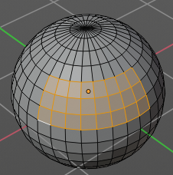
Fill Region
Select the region faces too.

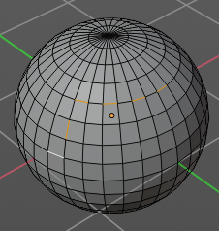
Nth Element
Don't select the whole path, but just every nth element of it.

Skip
This is connected to nth element. Number of elements to skip at once.

Offset
This is connected to nth element. Start with an offset.

More
Grow the selection.

Less
Shrink the selection.

